**Lab Assignment 7**

**Multiple Inheritance**

#include<iostream>

using namespace std;

class car

{

public:

char brand1[100];

char function1[50];

void getdatacar()

{

cout<<"Enter brand of car:";

cin>>brand1;

cout<<"Enter function of car:";

cin>>function1;

}

void displaycar()

{

cout<<"Brand:"<<brand1<<endl;

cout<<"Function:"<<function1<<endl;

}

};

class bus

{

public:

char brand2[100];

char function2[50];

void getdatabus()

{

cout<<"\nEnter brand of bus:";

cin>>brand2;

cout<<"Enter function of bus:";

cin>>function2;

}

void displaybus()

{

cout<<"Brand:"<<brand2<<endl;

cout<<"Function:"<<function2<<endl;

}

};

class vehicles: public car, public bus

{

public:

void displayall()

{

cout<<"Both are vehicles";

}

};

int main()

{

vehicles v;

v.getdatacar();

v.getdatabus();

cout<<"\nData\n";

v.displaycar();

cout<<"\n";

v.displaybus();

cout<<"\n";

v.displayall();

}

**Output**

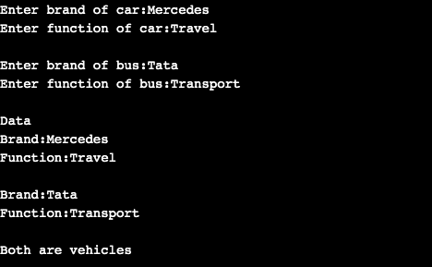

**Multilevel Inheritance**

#include<iostream>

#include<conio.h>

using namespace std;

class person

{

char name[100],gender[100];

int age;

public:

void getdata()

{

cout<<"Enter name:";

cin>>name;

cout<<"Enter age:";

cin>>age;

cout<<"Enter gender:";

cin>>gender;

}

void display()

{

cout<<"Name:"<<name<<endl;

cout<<"Age:"<<age<<endl;

cout<<"Gender:"<<gender<<endl;

}

};

class boss: public person

{

char company[100];

float salary;

public:

void getdata()

{

person::getdata();

cout<<"Enter name of company:";

cin>>company;

cout<<"Enter salary:";

cin>>salary;

}

void display()

{

person::display();

cout<<"Name of company:"<<company<<endl;

cout<<"Salary:"<<salary<<endl;

}

};

class chiefexecutive: public boss

{

int award;

public:

void getdata()

{

boss::getdata();

cout<<"Enter number of awards received:";

cin>>award;

}

void display()

{

boss::display();

cout<<"Number of awards received:"<<award<<endl;

}

};

int main()

{

chiefexecutive c;

cout<<"Enter data"<<endl;

c.getdata();

cout<<endl<<"Data"<<endl;

c.display();

getch();

}

**Output**

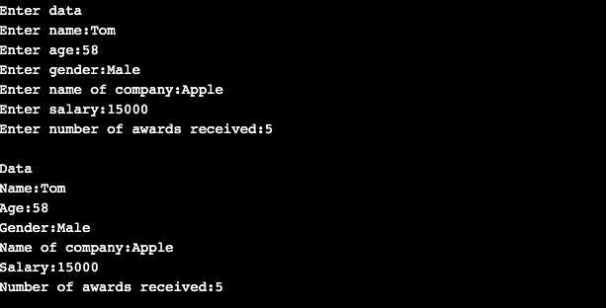

**Lab Assignment 8**

**Hybrid Inheritance**

#include<iostream>

#include<conio.h>

class student

{

protected:

int id;

char name[20];

public:

void getdata()

{

cout<<"Enter student name:";

cin>>name;

cout<<"Enter student ID:";

cin>>id;

}

};

class marks:public student

{

int a,b,c;

public:

void getmarks()

{

cout<<"Enter marks for three subjects:\n";

cin>>a>>b>>c;

}

};

class sports

{

protected:

int score;

public:

void getsports()

{

cout<<"Enter sports marks:";

cin>>score;

}

};

class result:public marks, public sports

{

int total;

float avg;

public:

void display()

{

total=a+b+c;

avg=total/3.0;

cout<<"Total="<<total<<endl;

cout<<"Average="<<avg<<endl;

cout<<"Average marks and sports marks are"<<avg+score;

}

};

void main()

{

result r;

r.getdata();

r.getmarks();

r.getsports();

r.display();

getch();

}

**Output**

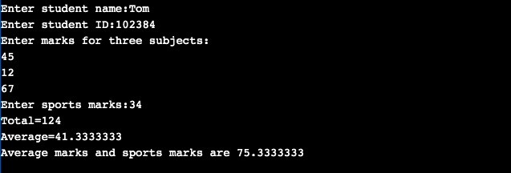

**Hierarchical Inheritance**

#include<iostream>

#include<conio.h>

using namespace std;

class person

{

char name[100],gender[10];

int age;

public:

void getdata()

{

cout<<"Enter name:";

cin>>name;

cout<<"Enter gender:";

cin>>gender;

cout<<"Enter age:";

cin>>age;

}

void display()

{

cout<<"Name:"<<name<<endl;

cout<<"Gender:"<<gender<<endl;

cout<<"Age:"<<age<<endl;

}

};

class patient:public person

{

char hospital[100];

int no;

public:

void getdata()

{

person::getdata();

cout<<"Enter name of hospital:";

cin>>hospital;

cout<<"Enter patient ID number:";

cin>>no;

}

void display()

{

person::display();

cout<<"Hospital name:"<<hospital<<endl;

cout<<"Patient ID:"<<no<<endl;

}

};

class student:public person

{

char college[100],course[100];

public:

void getdata()

{

person::getdata();

cout<<"Enter name of college:";

cin>>college;

cout<<"Enter course name:";

cin>>course;

}

void display()

{

person::display();

cout<<"College name:"<<college<<endl;

cout<<"Course:"<<course<<endl;

}

};

int main()

{

patient p;

student s;

cout<<"PATIENT"<<endl;

cout<<"Enter data"<<endl;

p.getdata();

cout<<"Display data"<<endl;

p.display();

cout<<"STUDENT"<<endl;

cout<<"Enter data"<<endl;

s.getdata();

cout<<"Display data"<<endl;

s.display();

}

**Output**

